**Document**

Xi Chen







Test Cases:

v = [420.9 1400 920 1452.6 9324 9600 37 655546 23132 333111]

Output:



Compared with the outputs with the supply function array from part c, the function works. But I did not get the right slope in part c, so some outputs are unreasonable large due to the wrong slope I put into the calculation.

**NOTES**

Part (a):

Part (a) is not too hard. Firstly, I find all the False by using find () function. Then, I subtracted the columns from the previous one to get incremental and replace the original value in the matrix. There are 10 possible pairs for the supplies and the prices so I divide the matrix into two columns with supply and its respected price. In this way, each row can form a 10*2 matrix. And then, I turned each row into 10*2 matrix and concatenated them nose to tail. Lastly, I sorted the matrix respect price column by using sortrows () function and attached another extra zero slope column to it.

Par(b):

Part(b) is really hard for me both in thinking and programming. I think the problem asks us to add the piecewise linear supply function together for each row.

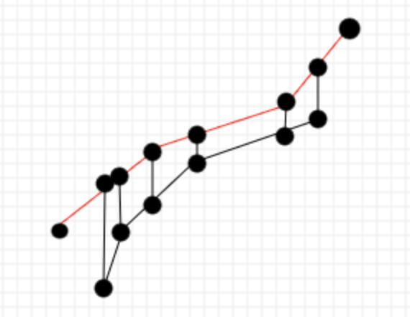

My thought is to combine each row iteratively. Since each line can be wrote as y = kx+b, two of them add up is y = (k1+k2) *x + b1 + b2. For the bunch terminal points which can be mapped to the other line, the mapped point has the same pi value (unit price). Moreover, we have the slope and one point on that line, so we can find the Q value (MWh) for the mapped point. We can create a new Q value by adding the Q value of these two points. The new point has the following propriety:

|  |  |  |
| --- | --- | --- |
| New P | New Q (if mapped point on second line) | New Slope |
| Same Price as Original P | Q=Q1+Q2=Q1+slope2*P+b | slope = slope1 + slope2 |

In this way, new points can be generated and we can use them to form a new PQ diagram. So, every time we absorb one row from the supply matrix and at last, we can absorb the whole matrix.

I have tried to turn this in code but I failed. The output I got is not acceptable. Instead of plotting something does not makes any sense, I chose to treat part (b) the same way as part (a) with the slope. The graph makes sense but I know I should do it piece wisely, otherwise, I cannot get the right PQ and slopes. I am sorry I really don’t have time to debug more because I have other homework due tonight.

Part (c):

For the part (c), we are supposed to add the step supply function to the piecewise supply function. I think the problem is similar with part (b) except we don’t add the slope because slope is 0 in step function. However, I did not get part (b) correct so I just treat all points as step and generate a sensible graph for part (d).

Part (d)

We are supposed to find the clearing price for the combined supply function. The demand function in the U.S. is close to a vertical straight line Firstly, I took care of some special cases such as negative demand, demand exceeds maximum supply. And then, we can search on the supply column to find the first point that satisfied the demand. If the supply exactly meets the demand, the clearing price should equal to the unit price at that MWh. If the demand is between two points include slope, we need to find the linear equation first and then find the clearing price on the line. If the demand is besides the step function with the 0 slope, we just choose the unit price for the step function.

Although I did not get my desired answer, I learned a lot from this assignment. The last time I used MATLAB was my undergraduate control system course. I didn’t recognize MATLAB has really good library to manipulate the matrix during that time. In this assignment, I get more familiar to use matrix to manage the data by programming in MATLAB and I also deeper the understanding of the economy basics.